Zion Hill Church’s

Woods & Waters

Sportsmen’s Fellowship

3064 Zion Hill Road, Millwood, GA 31552

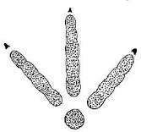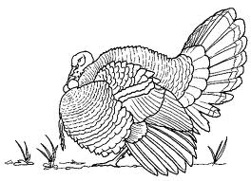

2022 “Big Bird” Contest

Saturday, April 2nd, 2022

$25 Entry Fee

Must be paid on or before Friday, April 1st, 9:00 PM

One half of the proceeds will go to Jep’s Job & Mattie’s Mission,
and the other half will be used as prize money.
Scoring will be by National Wild Turkey Federation standards.

1st Place – 30% of Entry Fee monies + Trophy
2nd Place – 15% of Entry Fee monies + Trophy
3rd Place – 5% of Entry Fee monies + Trophy

Scoring will take place between 11:00 am and 3:00 pm on Saturday, April 2nd, at the Zion Hill Church in Millwood.

For more info contact…

Riley Morris – (912) 592=1688 or Zeb Lloyd – (912) 816-8078

Zion Hill Church’s
Woods & Waters Sportsmen’s Fellowship
2022 BIG BIRD CONTEST
Registration Form
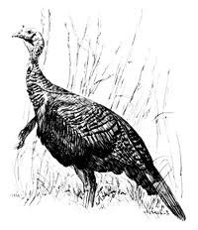

Hunter’s Name:
Address:
City, State, Zip:
Contact #:

$25 Entry Fee received by:

Any of the event volunteers of the Zion Hill Church may receive registration forms and entry fees. Registration forms and entry fees received by mail must arrive on or before Friday, April 1st.
Mail to: Zion Hill Church, 3064 Zion Hill Rd., Millwood, GA 31552

2022 BIG BIRD Contest Entry Receipt
This receipt has been issued to ,
as certification for his/her Registration and $25 Entry Fee into the Zion Hill Church’s Woods & Waters Sportsmen’s Fellowship “BIG BIRD” Contest, by .

Scoring of harvested turkeys will be according to National Wild Turkey Federation standards and will take place between the hours of 11:00 am and 3:00 pm on Saturday, April 2nd, at the Zion Hill Church, 3064 Zion Hill Road, in Millwood. Prize monies will be awarded in person and/or by mail.

